**Transmedia Storytelling Philip Corsius AC Day 20/10/15**

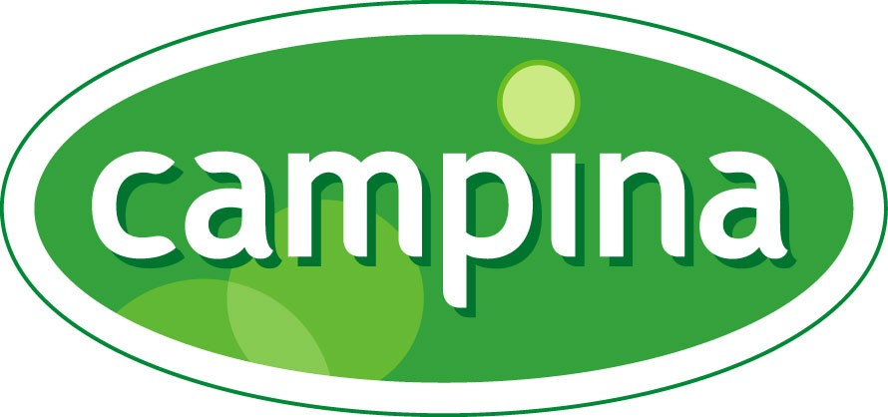

The Story Of Milk

**Yoeri Sweep**

**Kimberly Snoeren**

**Koen Schaaphok**

**Contents**

*Subject Page number*

**Part 1**

**1. The Company: Campina 4**

**2. Goals 5**

**3. Success Indicators 6**

**4. User Needs 7**

**5. Target Audience 8**

**6. Marketing 9**

**7. Concept 10**

**8. Back Story (Prologue) 11**

**9. Explanation 12**

**10. Charactarization 12**

**11. Tagline 13**

**Part 2**

**12. Rules Of Engagement 14**

**13. Platforms And Channels 15**

**14. Service Build Overview 16**

**15. Key Events 20**

**16. Business Models 22**

**17. Projections, budgeting & timelines 23**

**18. User journey 26**

**19. Multiplatform form 27**

**20. Interface & Branding 28**

**21. Synopsis, Plot Points & User centric scenarios 30**

**22. Peer-to-peer reviews 41**

## The company: Campina

*The business:*

Everyday, *FrieslandCampina* provides millions of consumers around the world with dairy products containing several valuable nutrients. With annual sales of 11.3 billion euros, they are among the five largest dairy companies in the world. FrieslandCampina supplies consumer products such as dairy drinks, baby foods, cheeses and desserts in many European countries as well as Asia and Africa.

Also, products are distributed through common trade, such as cream and butter products to bakeries and catering companies.

Campina desires to offer delicious dairy products at any time of the day.

From fresh milk, a vital part of any diverse and fresh breakfast and an active start of the day, to a whole range of dairy-related products.

In many countries dairy lovers enjoy the its products because they simply like it. But Campina is bent on promoting a healthy lifestyle and is highly efficient at communicating this message. According to Campina, that's the power of dairy.

In addition, FrieslandCampina produces ingredients and finished products for manufacturers of infant nutrition, food and pharmaceutical sectors worldwide.

*FrieslandCampina* has offices in 32 countries with over 22,000 employees and its products find their way to more than 100 countries. The central office of the company is located in Amersfoort in the Netherlands. *FrieslandCampina's* activities are divided into four market -oriented business groups:

*1. Consumer Products Europe*

*2. Middle East & Africa; Consumer Products Asia; Cheese*

*3. Butter & Milk powder*

*4. Ingredients*

The company is owned by dairy cooperative FrieslandCampina U.A., working with over 19,000 member farmers in the Netherlands, Germany and Belgium and remains one of the largest dairy cooperatives in the world.

*The story behind the brand*

Campina was the name of a large Dutch dairy cooperative whose roots go back to 1882.

In 2008 Friesland Foods merged with Campina and created the new dairy cooperative, FrieslandCampina. Campina continues to exist as a brand name for various dairy products.

Being milk providers with years of experience, Campina products have been a part of everyday life for many years now. It all began in 1882 when the first South Dutch dairy cooperative was founded in Tungelroy , Limburg.

Years later, in 1947 to be exact, Campina was the first official brand from the industry available in stores. Campina is therefore proud of this long and successful history, If only because the excellent taste of its dairy products remained consistent throughout the years. Since the post-war period, Campina merged with several other dairy companies throughout the Netherlands, as well as acquiring several smaller ones. These companies include noteworthy organizations from the Netherlands, Belgium, Germany, the United States, Argentina and many more.

This strategy eventually paid off, resulting in a nation-wide availability of Campina products and becoming the leading dairy brand.

Campina regularly makes good issues of both issues and trends circulating in the country. Examples of successful implementation are supplying Muslim customers with halal products and offering fair prices to local farmers for their dairy products and ingredients.

Besides this, Campina proved itself to be capable visionary company. Experimenting with new flavors, ingredients and products are often associated with its business model.

*Products*

Campina 's products are sold in supermarkets, kiosks, cafes and restaurants.

This range of products includes:

* Milk
* Milk foam
* Butter-based milk
* Coffee milk
* Coffee Cream
* Yoghurt
* Yoghurt Drinks
* Custard
* Whipped Cream
* Butter
* Cheese
* Pudding
* Milk sugar
* Milk proteins
* Medicinal ingredients
* *Valess* (milk-based substitute for meat)

## Goals

*Main (campaign) goal:*

From the perspective of the user through service, we want to achieve stimulating community-based storytelling experienced through a noticeable 30% rise in both online and offline contact between the brand and its customers 10 months after the start of the campaign.

*Process goal:*

Experimenting with never before tried multi-platform concepts and build a national community (all over the Netherlands) for the brand that achieves the aforementioned business goal.

*Economic goal:*

The economic/marketing goal is the successful execution of the campaign according to contemporary promotional/marketing/advertising standards that achieves the aforementioned business goals, as well as a noticeable increase in Campina product sales.

**Success indicators**

The aforementioned goals will be measured by means of both technology and informative interaction with stakeholders. This basically means evaluating during and after the campaign ends.

*Online channels:*

Campina wishes to find out if the required increases on various social media channels have actually happened using the technology available, as well as regular website visits and the *Traffic Per Lead Ratio* (how long did visitors stay? What did they do? Did they have special attention for more than a few parts of the website in general? Which devices are mostly used to access the online channels?) which can be measured as well.

This is a very important part of the evaluating process because it can give Campina relevant insights for further improvement. This can go from working on a better online framework for mobile devices to choosing to focus on different social media channels because visitors tend to use specific channels to access the online environment of Campina.

Online sales can easily be determined when taking a closer look at the sales numbers, as well as web shop visits or visits paid to the online channels of several partners. This could go for the regular partners of Campina or just companies affiliated with the campaign.

Counting online visits will show Campina the related *Cost Per Lead*, indicating if the costs justify the final results.

*Offline channels:*

The expected increase in store sales or the acquisition of goodies should be clearly visible throughout the campaign, making a final evaluation at the end a good finisher in order to get a clear view of the campaign success. The sales revenue gained by the campaign will reveal itself from an early stage on until the end, making it possible to compare the results to earlier expectations.

In the end, getting a profitable Return On Investment will be critical in order to consider the campaign to be a success. If Campina knows how to adjust the campaign in order to achieve more online visits, sales or general conversations between stakeholders, achieving a solid ROI becomes something that indicates the campaign as a success.

*Special engagement metrics:*

Besides the obvious online and offline ways of evaluation, Campina could work with result-based surveys as well.

This would mean interacting with both existing and potential customers and using these interactions to find out if they find the campaign pleasing. If so, Campina knows they are on the right track and efforts can be leveled up in order to gain more revenue. Should the answer be negative, it could provide for an even greater possibility. Now Campina can start the search for clarity. Why are people not responding in the way we anticipated them to respond? Is the campaign vague or perhaps overly simple? Are there certain negative feelings towards the brand Campina that make it hard for the campaign to overcome?

This kind of information is highly valuable to any company because it can provide for the answers necessary to adjust their strategy and reach the set goals.

Campina would select a range of both existing and potential customers for both quantitative surveys as qualitative interviews. Candidates are chosen to represent different groups of people within the response group. The group will include people from different backgrounds, social groups, religions, sexual preferences, business sectors and so on.

Using the information received, Campina can establish a clear view of the way the campaign is being received and what it would take to adjust it in order to gain maximum attention.

Should after adjusting the campaign the results remain below expectations, a total remodeling of the campaign might be in order.

*Remodeling?*

Remodeling needn’t be as devastating as it would sound. After all, a bad choice of advertising space in newspapers (both online and offline) or bad timing when it comes to commercials on the radio or television could play a part in it.

Evaluating the effect of all campaign-related advertising methods would provide for clear information as well. As long as the campaign is in effect though, the choices made are made through deliberation and should not be reconsidered lightly.

**User needs**

The reason why users will inevitably turn towards Campina is plain and simple: milk is a bare necessity.

There are some products society can live without and there are products that have proven to be vital. Milk is certainly one of them, as well as other dairy products. Throughout the Netherlands, families believe that milk makes you strong and a supplier of high-quality milk often finds his clientele coming to him instead of the other way around. And although competition exists, Campina has an excellent reputation to fall back on and a solid campaign can only gain more followers and therefore more customers for the brand itself.

In our society today, a lot of harmful food and drink products are being consumed on a daily basis and living your life in a healthy fashion is making a comeback. This trend is only one of the many reasons why any campaign or strategy issued by Campina will find its way to the consumer. This is because milk is, again, an essential product for family life. Not only families drink it often. Adults, sports teams, elementary schools and many more consumers exist. The list seems to be endless.

All these individuals provide for a big pool of consumers Campina can execute the campaign towards. It’s all because milk as a product holds it all together and Campina simply provides us with the possibility to do so.

Now we know milk is a necessity but why would people be interested in this campaign. Because few people actually know where milk comes from. Due to urbanization and modern ways of entertainment for today’s youth, interest in this matter isn’t as high as it once was. Of course, we all know milk comes from cows but what happens after the cow is milked? Does it go straight into the milk cartons? The entire process following the actual milking is unknown to many people and our campaign will provide an insight in how it goes from that point on. It’s educational and encourages consumers to find out about the origin of what they eat and drink on a daily basis.

**Target Audience and Marketing**

*In brief:*

Campina wants to use storytelling in order to show the actual story behind milk to inhabitants of the Netherlands. Not only the origin of milk will be shown, but the preceding production processes as well. not only Campina is willing to let the audience participate in an online tour of making milk so they can virtually make their own milk.

This is where gamification steps in: the audience will follow the storyline and has to perform tasks to receive an amount of milk (currency / points). Throughout the story they will receive different achievements that will be displayed on their Facebook-page. When the highest achievement (Milk farmer) has been achieved they will get a small milk-bottle with their name and title on it (Milk farmer).

With this campaign, Campina wants to create awareness around their brand and incite people to drink milk.

**Target audience**

*Demographic factors:*

The transmedia storytelling concept is targeted towards consumers in the cities. Research shows that a lot of city-people don’t know where milk actually comes from, what products are made out of milk and what the steps of production are.[1] [2]

Because a lot of (especially younger) inhabitants don’t know about where milk comes from and how it is produced, Campina will target the campaign on people from between 6 and 40 years old. Campina wants to inform kids, the youth and the parents because they are all able to attend the telling of a story and participate in the game at their own pace.

The campaign can be interesting for inhabitants from villages of other parts of the Netherlands as well.

For Campina it’s a perfect chance to create brand awareness in the Netherlands, become a top of mind product and get milk to be the number one discussed subject during the campaign.

*Psychographic factors*

The target audience is very big because Campina desires more than simply showing the Dutch people where milk comes from and how it’s processed but also because it wants to create brand awareness and make milk the topic of the day.

The target audience consists of people who eager to learn, who are easily sucked into a story and who are easily ‘addicted’ to gaming. Campina doesn’t want to quickly inject information but it wants the audience to stay focussed on their product and their company for as long as possible (Storytelling / game).

Also, Campina wants to attract people to their story who are very sensitive to brand connecting.

By making the story come alive through different types of media like television, social media and billboards, Campina wants to attract people to connect with their story.

The audience also needs to be active on social media and have knowledge on how to play an online game on Facebook or mobile devices.

**Marketing**

The goal of this campaign is to create brand awareness for Campina and make milk top of mind as a product. Campina wants to achieve this by immersing the audience in the world of milk and keep them there as long as possible.

The audience will be lured into the story of milk by using a lot of different media to frequently get the story under the attention of the audience. Where (for example) the audience will be asked; ‘Do you still know where milk comes from? You think you do, but why don’t show us?’ or ‘Want to know where milk comes from? Start playing and become a real milk farmer’. Then they are asked to go to the website or download the app to play the ‘The story of milk’ game.

Because most people like to be challenged and like learning or showing their knowledge, a lot of people will probably start playing the game. Inside the storytelling game they will need to do a lot of assignments to earn milk (points) and in order to succeed some assignments, they also need some Campina milk.

During the storytelling game, achievements earned by players will be shared on Facebook. The players begin as *Silly Milly* and end up (highest rang / achievement) as Milk farmer. The shared achievements will provide extra publicity.

Customers can use these achievements to get discounts or other additional things after buying a litre of Campina milk. People (especially from the Netherlands) are very enthusiastic about getting free things or getting discounts so this will provide for a good image of the brand from of the customers’ perspective and therefore they will easier connect to the Campina brand.

After the game (when they reach the highest achievement / rank) they will receive a 0,5 litre bottle of Campina with their name on it (above it says Milk farmer). The point of all this is that they will (hopefully) take it to class or work. When proudly drinking from their custom made bottle, a lot of silent publicity can be established.

**Concept**

Campina wants to use storytelling to show inhabitants of the Netherlands what the actual story behind milk is, instead of only showing them where it comes from but what the production process is and what precedes it as well.

Campina wants to educate about milk by taking them on a gamification-tour game. They will follow the whole (trans-medial) storyline of making milk and will have to successfully complete different tasks to show that they have what it takes to produce milk.

For example, the game would be similar of the Coca Cola campaign ‘Happiness Factory’. The game will be available as a mobile application but will be playable online as well.

The audience follows the ‘Story of milk’ and performs tasks to get further into the story; each step (level) has different tasks (stages). When a stage (task) is finished successfully they will receive currency (millilitres of milk) and a short story will be shown.

When a level (step) is finished successfully a part of the story of milk (like Happiness Factory) will be revealed. At the end of the game they will have gathered the complete story of milk.

The currency (millilitres of milk) is exchangeable for different products, for example, discount vouchers on a certain Campina product or just another task to perform.

The audience also gains different achievements, which will be shared on Facebook.

Sharing these achievements will provide for extra publicity on Facebook.

Right now, one would probably think: *This is a game, but what’s trans-medial about it?*

The trans-medial part lies in the stages (tasks) that the player has to play through.

As aforementioned, the game/story has several tasks. To successfully complete these tasks, some will require only to play the online game. Some other tasks also need the player to watch the related YouTube video accompanied by it, watch a certain program or commercial, make or bake (task) something using a Campina product, get information out of the inside of a packaging or perform a virtual reality (or film it) task.

There are also ‘tasks of the day’ through which the players can collect more currency or get an additional prize.

If the players have finished the game they will have the story of milk completed. This provides for the highest achievement ‘Milk Farmer’, which they can proudly share on Facebook. Also, by reaching the highest achievement they will be rewarded with a Campina (half litre) bottle with the title Milk Farmer on it and their name.

The point of this is that they fill it and, proudly, take it to work or class, which will create a lot of silent publicity.

**Back Story (Prologue)**

One day, while his parents were at work, Kyle took a little walk and took his backpack with him to collect stuff he would find. It was pretty dangerous because Kyle lives in the middle of a big city, where loads of cars cross by and where a lot of strange people walk around.

Eventually, Kyle reached a rather calm part of town and Kyle loved that because of the lack of cars and the presence of nature.

He reached a large forest filled with all sorts of wildlife like bunnies and deer.

Seeing these animals only on TV, Kyle thought: ‘That was quite cool to see!’

He also crossed several large houses with a lot of grassy areas surrounding them. That seemed weird. ‘Why would there be so much grass next to a house?’ Kyle quietly asked himself. ‘It’s probably being used to play football but it isn’t wise to put barbed wire next to it because it will probably puncture the ball.’ Kyle figured.

Kyle had never seen this before. It was already getting late so Kyle thought it would be best to turn back. He went back through the forest, hoping to spot even more types of wildlife. After walking for a while and picking up a lot of acorns to bring back home, he suddenly heard a blaring noise coming from his right. It sounded like an animal in distress so Kyle quickly ran towards the sound

Wow! It was a young calf trapped in a ditch from where it couldn’t get out. ‘I can’t leave that sweet calf being trapped in the ditch’, Kyle thought as he decided to try and push the calf out.

Using all his strength, Kyle pushed the calf out. Although he wanted to stay with the unfortunate animal, Kyle had to go back home so he quickly resumed his journey home. After a few steps he felt a little push. It turns out the Kyle was being followed by the calf. Kyle laughed and urged the little thing to quit.

Having no idea on which name to give the young cow, Kyle noticed a black spot covering the calf’s left eye and instantly yelled ‘Stop that Spot!’

Having come up with a good name for the calf, Kyle realized it was impossible to take Spot home with him. His parents would disapprove of him having a calf at their home, let alone that he had been out that far by himself.

Spot didn’t seem to mind as she kept on pushing her head into Kyle’s backpack.

After a while Kyle remembered that he filled his backpack with acorns, couldn’t that be what Spot was after?

Kyle stopped and handed some acorns to Forest. Before he could even blink, the calf had eaten them all.

Watching the young calf eating all the acorns, a strange thought ran through Kyle’s head: ‘Is it possible that this calf is just crazy for acorns? I thought cows and calves only ate grass.’ Seeing how the calf seemed to love the acorns, Kyle decided to lay the matter at rest and simply go with it from that point on.

Reaching the deepest part of the forest, Kyle and Spot spotted a small house hidden behind a lot of trees. Kyle took a look inside. It was totally empty and it didn’t seem that anybody had been in there for a long time.

He noticed another field of grass and a ditch filled with water near to the house.

Kyle wondered if this would prove a good place to leave Spot, since he couldn’t bring her home with him. He threw all the acorns he had left on the ground near the cabin and left the door open as Spot started eating them all.

Kyle quickly ran away and went home, reaching is room just in time in order to avoid getting caught by his parents. ‘That was a close one!’

Since that day, Kyle went to check on Spot every day and they soon became best friends. Spot has grown a lot and already became a big cow, but lately Spot seemed to be a little unhappy, like something is missing.

Kyle really wanted to help Spot but he didn’t know what was wrong with her.

One day, on his way to the house in the forest, he heard some people talking about ‘milking a cow’. ‘Could this mean that Spot needs to be milked too?’

But how could he do that? Does this mean that the milk as we know it actually comes from cows like Spot?

‘That’s amazing! But how does it work? Could this be the very thing that will make Spot happy again? I need some help!’ Kyle thought to himself.

Are you the one that’s going to help Kyle and Spot make milk and become a team?

**Explanation**

The story above is a prologue used to provide the history of Kyle and Spot. After telling this part of the story, the campaign starts and players are directly involved in the telling of the story as it develops.

We then ask the audience for help solving the problem.

Parts of the story will be shown on different media to get the attention of the audience.

The story will be told as a summary of events.

**Characterization**

*Spot*

Spot is a happy black and white calf that can’t provide milk yet. She got her name after the distinctive black spot covering her left eye.

The audience will step in during the time when Spot has grown into an unhappy black and white cow that is mature enough to start producing milk but doesn’t know how.

*Kyle*

Kyle is a 10-year old kid that lives in the middle of a big city and that doesn’t have a lot of knowledge about the countryside. Kyle has blonde hair and blue eyes and may at times be a little adventurous.

He represents the youthful spirit curious about the way things work and he chose the process of producing milk as something he wants to learn as much about as he can.

*The Player*

The player helps Kyle and Spot along the way by gaining achievements and solving puzzles. If the player manages to complete the steps and gain the necessary achievements, Kyle and Forest can continue their adventure. If the player fails, so do they.

*The Huntsman*

Watch out for the huntsman; don’t let him get to Spot. The Huntsman is a very scary man, with a big scar underneath his eye. He wants to capture Spot but no one seems to know why. He’s very dangerous and won’t hesitate to harm Kyle if he gets between him and Spot.

He is also very rude to humans so make sure he doesn’t see you. Make sure Kyle and Spot always stay ahead of the Huntsman so he never gets close to them.

* Turns out to be good in storyline 2 (there are 2 possible timelines) *

*Pete*

Mysterious man who tells Kyle to call him Pete and just steps in occasionally.

He seems to be willing to help Kyle and gives him advice, he also seems to know a lot about milk.

He is still a little bit strange. He is always gone instantly and Kyle is not able to find Pete.

* Tries to help Kyle because the Huntsman once took one of his cows that looked very much like Spot * (Storyline 1)

* Proves to be the evil mastermind behind everything * (Storyline 2)

*The vet – Doctor Tom*

The Vet is the number one inseminator of The Netherlands and was captured by the Huntsman before Kyle broke him out. The Vet is a very kind man and is going to be a great ally.

**Tagline**

We’ve decided to go for a tagline that leaves some room for imagination while preserving the goals a player needs to reach, combining everything with a bit of adventure attached to the feeling we want the user to experience.

*‘The journey begins’*

**Rules of Engagement**

*1. Terms and conditions:*

Personal information

Before players are able to register for the entire campaign, they are asked to agree with the terms & conditions Campina requires from them.

These rules were set up because the transmedial storytelling campaign makes use of several media of which some need user-specific information in order to execute the campaign in a solid way. Potential players need to give Campina access to their personal social media information so the achievements can be shared on Facebook. They also need internet access to play the games.

This information can also be used to design certain moments during the campaign on a very personal level.

For example, when an on-screen message from Kyle appears before the player, he may reference to certain personal pieces of player information indicating he knows and recognizes the person playing the game. He gets this information from social media channels, as well as from players themselves when they register for the campaign.

Phone camera

Another important part of the terms and conditions is the permission to use pictures players take with their phone camera for Campina purposes.

In order to successfully perform tasks, sometimes the campaign may ask participants to take pictures or selfies and post them online.

The final goodie (the carton of milk with the participant’s picture on it) requires permission to print as well, incorporated in the terms and conditions.

*2. Campaign duration:*

The campaign will remain active for a period of at least 6 months. This is always open for discussion. Should the campaign still be very popular after this period, it can easily be extended In order to make sure everybody gets to experience and play through it.

It’s understandable that not everyone will register for the campaign after the initial encounter in the supermarket.

That’s why the images of both Kyle and Spot will have a lingering effect on the customer standing in the aisle looking at what new idea Campina has launched this time.

It might take a few visits before people will engage themselves to the campaign and give it a try. Therefore it isn’t that illogical to assume that it might take a few weeks before the desired effect is reached and a large number of customers registered for the campaign.

Should there be obvious signs that lengthening the campaign would prove fruitful for the campaign’s success, it’s only a matter of re-running different media commercials and keeping the cardboard advertisements in the stores a bit longer.

When the campaign is to be concluded, it will no longer be possible to play the games online or scan the codes found on milk cartons. Re-watching clips on YouTube remains possible, as well as ordering personalized cartons for those who achieved the highest Milk Farmer-rank.

*3. Periods of access*

Players will have access to the campaign as long as the campaign is running.

This means that, to avoid discouraging players, they can take as much time as needed to gain all the achievements and play, view and work through the different stages of the campaign.

Although the idea of presenting players with a fixed time limit to boost playing time came up at a certain time, we decided to not go with it.

This would mean punishing players for going at their own pace and forcing them to replay different scenarios several times.

This would probably take the fun out of playing through the campaign and may stop them from playing altogether after a while.

If players haven’t reached the end by one month before the end of the campaign, they will receive a notification by e-mail telling them that if they wish to have their own personalized milk carton, they should think about finishing sooner or later to prevent missing out in the end.

*4. Retreat*

When a players remains inactive for a scripted amount of time, he or she will receive an e-mail notification saying that Kyle and Spot have been stuck at their current stage for a while now and inviting the player to help them.

Should a player wish to quit playing and no longer receive notifications or updates, he or she will receive a video in which Kyle thanks him or her for the help received and lets the player know he and Spot will continue their journey.

At any point, the player can choose to continue his or her quest, disregarding the fact that the player previously decided to quit.

The player is then able to pick up where the adventure stopped and is able to continue without having to start all over again.

**Platforms & Channels**

The campaign consists of different media (channels/platforms) throughout which the player has access to the campaign.

When playing, everyone will eventually pass through all the channels because every channel is vital in reaching the next stage and gain the associated achievement.

The channels used in this storytelling campaign are:

*App:*

A mobile application will become available for download the day the campaign starts. It will support all major smartphone brands.

The primary use of app will be to keep track of one’s journey so far and play some of the games at any time. Several mini games will launch throughout the campaign as well to tune up the factor of entertainment.

An important aspect of the app it the ability to use it for scanning codes found on Campina products.

*Website:*

The website will serve as a hub of the campaign. Players can access the website for information, games, statistics of their efforts so far and upload pictures of themselves, their location or the achievements they gained.

The website will be a stand-alone entity, meaning that it’s not a mere part of the Campina website but an independent part of the internet.

*Social media:*

The campaign supports the channels of Facebook, Twitter, YouTube and Instagram.

The first two will be primarily used for sharing achievements and collecting feedback on their online message boards. YouTube will serve as the main location for all the videos of the campaign, both the uploaded ones from players and the official story reels of the campaign. Instagram will push users to give their pictures a special filter.

*Television/radio:*

These channels are used for broadcasting. Mainly commercials but some of the achievements may include watching or listening to a certain program at a specific time because a vital clue for gaining the next achievement may be released.

*The stores*

Of course, players may be asked to buy a specific Campina product in order to get further in the game, there’s a code underneath the cap or on a paper inside the package (cheese) that they will need to enter in the game. They might even need a specific type of a certain product.

Perhaps they need to travel to another part of the Netherlands to find a specific product associated with the regional identity. The journey doesn’t end on your own doorstep.

Earned millimetres of milk in the game are exchangeable for discount coupons and other Campina branding products or The story of Milk merchandise (Kyle and Spot-dolls et cetera)

**Service build overview**

The campaign will be designed as an interactive adventure, allowing players to move from one medium to another freely, gaining rewards (achievements) and learning the story of milk while doing it.

*Launch*

Starting weeks before the actual launch of the campaign, commercials on television, radio and YouTube will air.

These commercials will be designed to trigger the curiosity of the audience and inform them of the possibilities and how to register to participate in the campaign.

Shortly after the start of these commercials, Campina will organize a marketing campaign in stores selling their products, repeating this message.

This way, those yet not reached by commercials will come into direct contact with the campaign where it matters most: the shelves selling Campina products.

One week before the start of the campaign, the online channels (website, social media channels, app) will go online displaying a timer.

Several of these online channels have been beta-tested during the previous weeks by specialized game testers, in order to eliminate bugs in the games and guaranteeing a flawless game experience.

After a week-long countdown, the timers will hit 0 and Kyle and Spot can start inviting players to start their journey.

Prior to this moment, the audience already got a chance to meet Kyle and Spot but doesn’t have any information on who they are or what they are going to do.

This is important to retain an air of mystery prior to the official start of the campaign.

*Working on constant revision*

It’s difficult to accurately foresee how the audience will experience the campaign and if it will be a success or not.

In order to prevent a sudden stop in the flow of new players joining the nation-wide journey, developers will work on additional content from the start of the campaign until a month before the end.

This content can be released should the audience clearly desire other ways of entertainment. This could mean more movies, games or out-game tasks. With having them ready, Campina can easily adapt to the demand of players all over the country.

Developers are monitoring the campaign’s popularity every day. When noticing any irregularities, (the amount of players dropping, some channels are barely used, …) they can quickly discuss possible solutions and edit the campaign by inserting the aforementioned content or start a conversation with players on social media.

This is why it’s very important to listen to what the audience wants. If they don’t like something, it should become a priority to make sure the campaign meets their demands.

If people stop playing, the campaign is useless and Campina won’t see their client amount going up and it will inevitably be considered a failure and this negative image will soon spread to Campina itself.

*The end*

As mentioned before, the campaign can be lengthened if its popularity is to provide enough reason for it. Signs indicating this could be the amount of players staying constant during the campaign or a strong desire from the social media channels to keep the game available for playing.

Should this not be the case, then the campaign obviously will be terminated after its 6 months of running time. Players will receive notifications that the adventure of Kyle and Spot is about to come to an end and that they should finish their quest if they still wish to attain the status of Milk Farmer and receive their personalized milk carton.

During the final week of the campaign, several videos normally only seen when you complete the Story Of Milk, will be posted online anyway.

In this case, those who didn’t finish their quest can still see how the story would have ended.

After closing down the campaign, the social media channels remain open for a significant amount of time. This way, post-campaign information from players can be received.

Campina can use these opportunities to find out if the Campina image changed because of the campaign. How did customers perceive the Story of Milk? Did they learn from it? Do they feel Campina to be a reliable partner when it comes to dairy products?

The campaign can officially end with an ego-booster. This could best be a short video displaying the effect the campaign caused. How many people played the games? How many personalized cartons were produced?

If the campaign was a huge success, a video displaying the impressive statistics can work as proof of Campina’s power and likeability.

*Holiday specials*

Incorporating out-game events in the campaign never fails to receive attention.

Should the campaign be scheduled between October and April, several Dutch holidays can be included in this process.

Holiday specials include several aspects. There is the esthetic part of the campaign. When players are playing through the campaign during Halloween, the surroundings of the location Kyle and Spot are venturing through display a lot of broken trees, ghosts flying through the air, it’s 24/7-night time and Spot is wearing a spooky mask.

The same could go for Christmas. Suddenly, the entire adventure takes place in the snow.

Perhaps during Kingsday, the King of the Netherlands is watching the duo pass by while wearing his crown and leaving behind orange-colored glitter.

Gameplay could be influenced as well. Different themed mini games or side quests could revolve around the holiday taking place at that very moment.

Santa has a big problem because his sled crashed near the milk factory where Kyle tries to sneak into. If Kyle would kindly find Santa a screwdriver while performing the main objective, Santa could fix his sled and offer a small token of appreciation to Kyle.

Kyle and Spot could even be recruited as ghost hunters during Halloween, encouraging the player to explore every part of every level because of the additional reward that comes along when the player locates every ghost hidden in the game.

Should a real-time event take place and everybody talks about it, why shouldn’t Kyle and Spot?

*Co-op playing*

Although designed as a single player campaign, it is possible for players to interact with each other throughout both adventures.

To prevent the games becoming too easy because players team up and then work through the campaign in a short time, co-operation will be limited to exchanging items and compare scores.

Besides this, certain mini games will be playable in a special Versus-mode.

For example; players can shoot bottles of milk of a fence together with the victory going to the player who can shoot the most milk bottles in a one minute-period. Other co-op applications could include one player being invited to play a game another player has trouble with and if he can manage completing it, rewards will be split 50/50.

Of course, the campaign remains meant for one player at a time but time will tell if multiplayer could prove for a fresh impulse for those playing the game. Should more co-op possibilities be something a lot of players look forward to, enhancing the multiplayer functions could be something to think about.

**Key events**

Key events are represented throughout the campaign by the different stages players can reach. These are known as ‘achievements’ and are meant to reward the player for the effort he or she put in the campaign. The different achievements are as followed:

*Achievement 1: Silly Milly*

This is the initial achievement every player automatically reaches after watching the intro.

Although it may sounds a bit mocking, it serves as an encouragement for the player to start progressing.

*Achievement 2: Hello, World!*

Kyle managed to find out how Spot is best to be milked. After escaping the grassy planes and areas they are accustomed to, it’s finally time to start adventuring for real.

*Achievement 3: Escapist.*

Kyle has freed Doctor Tom in order for Doctor Tom to inseminate Spot. This way, Spot can start producing Milk. He manages to escape before the Huntsman gets there.

*Achievement 4: First Farm*

For saving The Vet (Doctor Tom), Pete gives Kyle a big farm with 2 cows and 2 calves after he found out what The Vet’s name is.

Achievement 5: Full Bucket

Because of his new cows, Kyle finally managed to milk his first cow and he got a full bucket right away!

Achievement 6: First Contract

Dr. Tom told Kyle that the milk needs to be cooled. Kyle went searching and found the milk container. When he found it, it felt like everything was left in a hurry.

Achievement 7: Quick Milking

Kyle and Dr. Tom got 10 more cows from the factory that hired Kyle’s farm. Now they can’t milk all the cows manually anymore. That’s why Kyle tries to re-start the milking machine.

Something went wrong, so Kyle needs to collect as many Milk cans as he can.

Achievement 8: Know it all

Kyle finds out the true story behind Pete. How will he react to this?

Achievement 8: Showdown!

The Huntsman/Pete surprises Kyle. Kyle needs to react fast and save himself and the rest.

Achievement 9: Milk Farmer

Kyle and Spot did it! The Huntsman/Pete is defeated and their Story of Milk is complete! Now Spot can finally start her destiny as a milking cow. The player is now free to play all the mini games he/she wants and can start customizing the personalized milk carton!

# Businessmodels

A business model is the story of how value is created, delivered and captured. The type of business model is a campaign. You can find the business model for The story of milk campaign below.

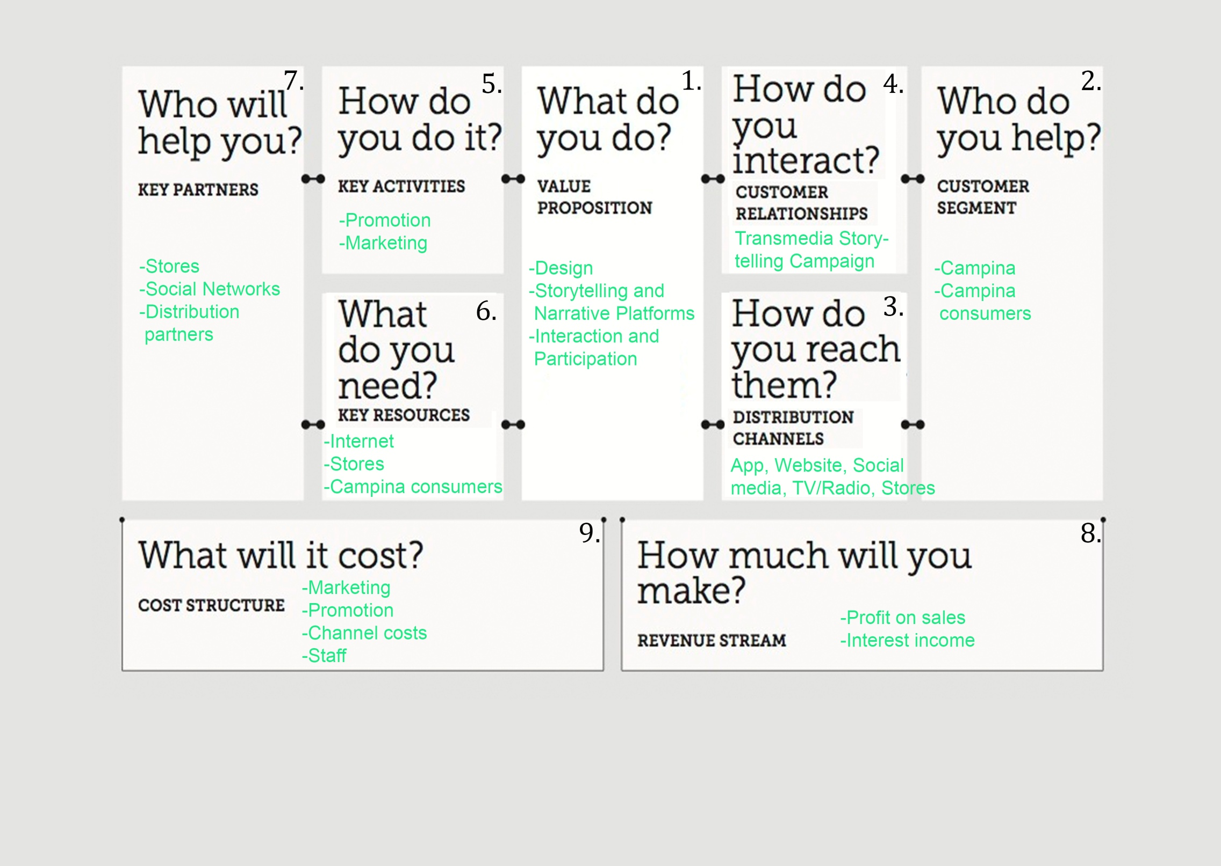**Projections, budgeting and timelines**

This section will detail the important costs and likely revenues and proﬁts from the service. It include a spreadsheet listing how much the service will cost to build, and may develop in granularity as the service planning moves forward.

The campaign consists of different media (channels/platforms) throughout which the player has access to the campaign. As seen in the business model of the campaign, the revenue will come from profit on sales and interest income. The costs structure for the campaign will be marketing, promotion, channel costs and staff. The channel costs will be for making the application and the Story of Milk website (approximately €1.000,- for Application and €2.500,- for the website) (000.nl, 2015), staff costs for keeping up the social media channels (Facebook, Twitter, Youtube and Instagram) and costs for the primetime spot on television and radio (approximately €175,- for television and €100,- for radio). (Ster, 2015)

The process of creating successful transmedia storytelling campaigns necessitates careful planning, optimally in the early development phase. The projections and timelines are worked out on the next page.

|  |  |  |
| --- | --- | --- |
| Service | Time | Costs |
| Application | 9 months | € |
| Website | 7 months | € |
| Social media  (Facebook, Twitter, YouTube and Instagram) | 10 months | € |
| Television | 8 months | € |
| Radio | 8 months | € |
| The stores | 6 months | € |
| **Total costs** |  | **€** |

### Projections and Timelines of The story of milk campaign

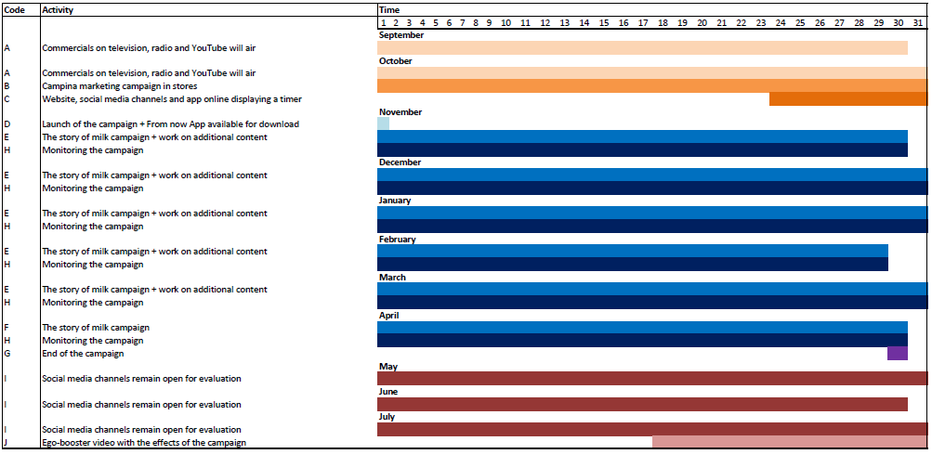

# Production team

The multi­‐disciplinary team consists of three people. Kimberly Snoeren, Koen Schaaphok and Yoeri Sweep. For the next eleven months, they will work to create a transmedia storytelling campaign, named ‘The story of milk’. The goal of this campaign is to create brand awareness for Campina and make milk top-of-mind as a product. To realize this, the team needs to have a certain kind of structure with transmedia roles and responsibilities.

### *Structure:*

The production team consists of three members. Below are their names, sorted alphabetically on their last name.

* Koen Schaaphok: Team leader
* Kimberly Snoeren: Planner and designer
* Yoeri Sweep: Content writer

### *Definition of the roles:*

Planner:

This person will decide on deadlines. It is up to him/her to ensure everybody knows when something needs to be done. The planner will also outline the process of the campaign for each day until the final deadline.

Content writer:

He/she will be seen as a general content writer for the campaign. This may involve creative writing, concepting, providing an analysis or any other relevant aspect of the project’s documentation.

Team leader:

This person will take on a leading role during the campaign. The team leader does not have absolute power in the team: the opinion of every member is just as important as his/hers. The team leader is there to keep the meetings organized, to ensure deadlines are made and to notice and set up help for team members who are struggling with a particular assignment.

Designer:

This person will be responsible for creating the visuals of the ‘The story of milk’ campaign. This can be creative designs, but also graphics to show statistics for backing up the campaign.

# User journey

The user journey diagram’s accompanying notes shows how a user might move through a transmedia narrative. Time (the achievements/levels) is mapped on the horizontal axis and the media channels on the vertical axis. The diagram provides a clear picture of the dependencies and bridges between each component of the transmedia narrative.

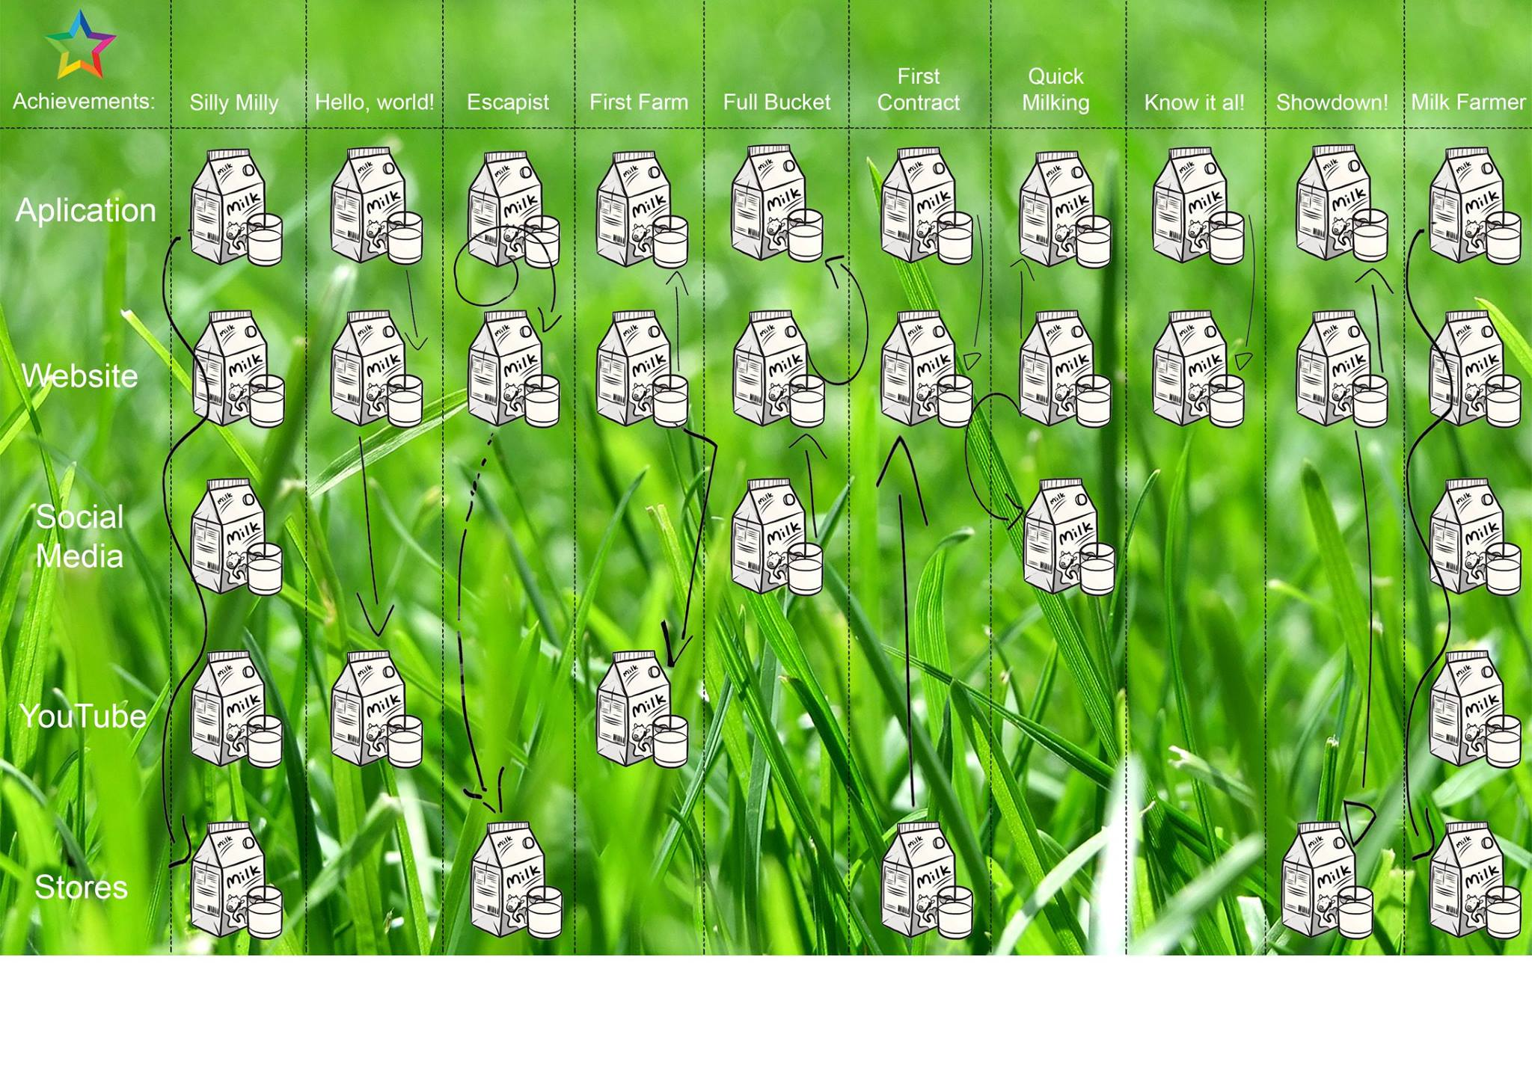

**Multiplatform form**

The campaign will be available on different channels and will have different channels referring to it in a non-interactive way as well.

*The game*

The game is what connects all aspects of the campaign together; the game only has one entry point (beginning), but there are several channels that refer to the game. Parts of the prologue of the story, or the prologue entirely, will be shown on media such as video commercials, radio, billboards, Social Media and packages.

The game is playable on IOS, Windows and Android phones by downloading the app ‘The story of Milk – Campina’. But it is also playable on the computer via a special ‘Story of Milk – website’ or via Facebook.

*Tasks*

The game gives the player different tasks that the player has to succeed. These tasks can be very different and because of that a lot of different channels and platforms are used.

Some tasks may require the player to buy a specific milk-based article of Campina for further development of the game and story. Also, for some tasks the answers can be found in movies on Campina’s YouTube account, Campina’s Facebook account, stated on a Campina product, established outside on special occasions or television commercials of Campina.

*Mobile phone*

If the game is played on mobile phone, the app will require permission to use the camera of the players’ mobile phone in order to succeed into some tasks.

One of the tasks that can be succeeded in using the camera is milking a cow. The game switches the camera on; the player has got to place it so his or her hands are being filmed (in selfie mode). The player will see Cows’ udders and has to milk it by moving the hands up and down as being showed in the introduction movie before the task started. The Cows’ udders will colour green if it’s done in the right way. The faster the cow is milked, the more milk the players earn.

*Computer*

If the game is played on the computer for the same task as explained above, the app will require permission to use the players’ webcam. The same task as explained above will have to be completed using the webcam.

**Interface and Branding**

*Main Interface*

The game will have a starting point; the starting point is the players’ home base. At first they will start with the cabin in the woods (where spot is being kept by Kyle as told in the prologue), 2 strokes of grass next to the cabin and a ditch filled with water.

Throughout the game they will need to improve their home base (building more buildings / facilities).

In the upper left corner, Kyle (main character) is shown wearing a t-shirt with the Campina logo on it. If the player clicks on Kyle, Kyle steps into the screen and gives the player advice (spoken and written, comic wise) about how to continue the game (story).

In the lower right corner, there is a menu button (written in a can of Milk).

If the player clicks on the menu button, the player can find general information about the game.

At the top of the interface all players’ possessions/materials are shown.

These possessions are millimetres of milk and a number of Cows. At the left, Kyle’s bag pack is shown with ‘Missions’ on it. Also, underneath the bag pack a watch is shown, the watch is the mission of the day tab.

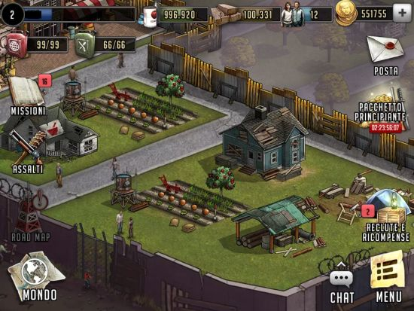

*This is an example of the main interface (the players’ main base). – The Walking Dead: Road to Survival –*

*Mission interface*

When the player clicks on the ‘Missions tab’, the player will open up a new screen.

The screen shows a path (storyline) which the game leads the player through. The story is only viewable until the point where the player is at that particular moment.

The other parts are still vague; the first level starts ‘Empty Udders’ and will go past places like for example ‘The big Milk-Farm’.

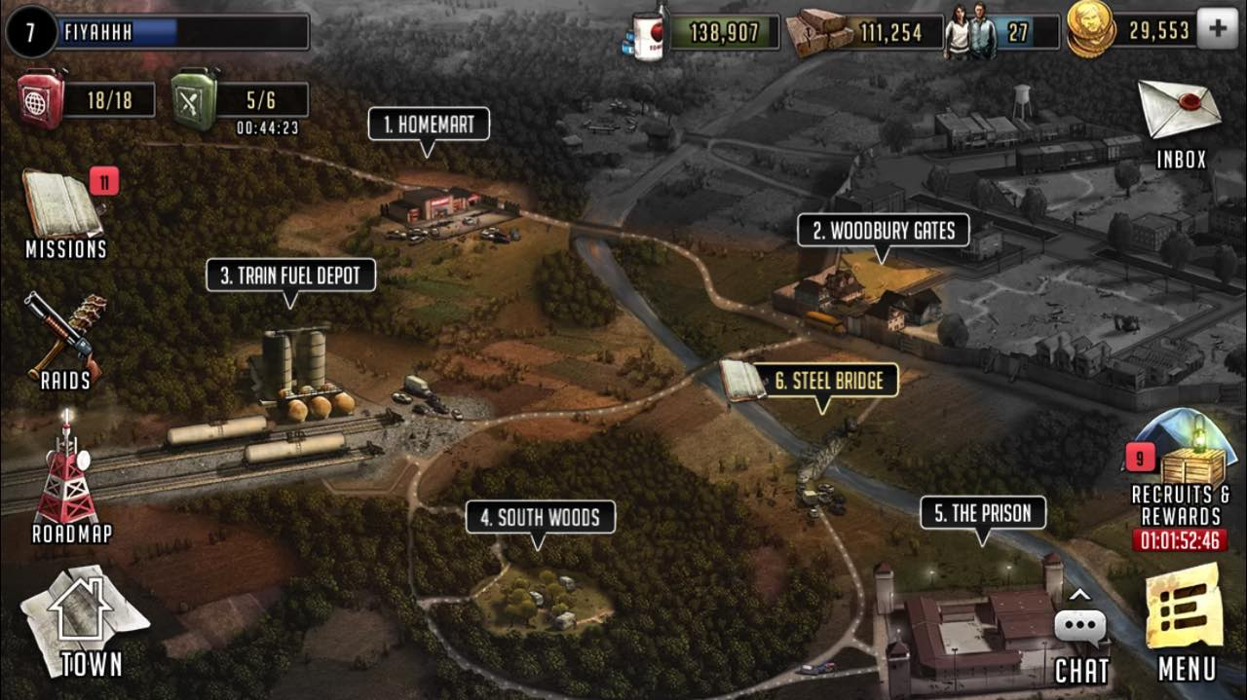

*This is an example of the missions’ storyline. – The Walking Dead: Road to Survival –*

Each Mission (level) will have a few tasks (the amount varies per mission). While starting a new mission or new task the storyline will further develop. For example, by dialogue between Kyle and a third person or Kyle telling something to the player. After succeeding, a movie starts about what Kyle has learned of the experience.

Sometimes the player has to make a choice whenever Kyle is unsure about something.

A right answer can result in extra milk currency or other rewards.

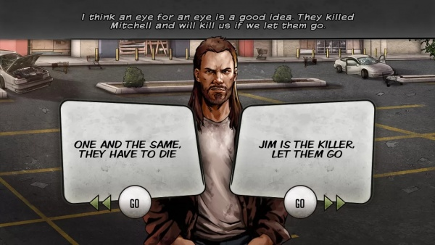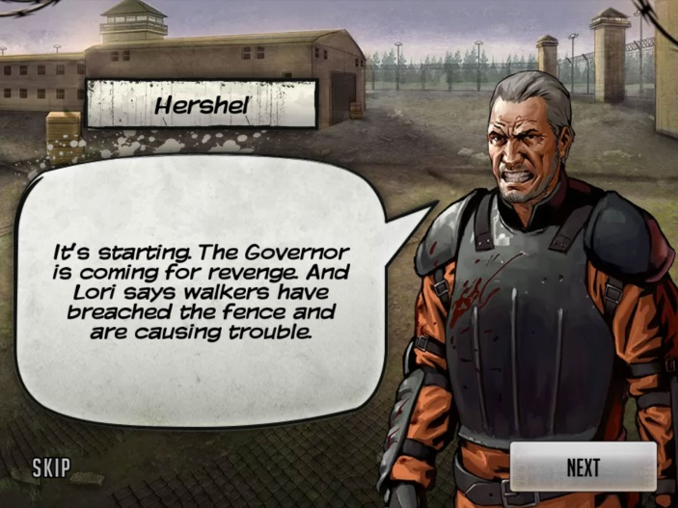

*This is an example of the storytelling part within the missions. – The Walking Dead: Road to Survival –***Synopsis, Plot points and User centric scenarios**

In this chapter, the story will be told in order of the levels in the game.

Each level will have a short explanation of the synopsis, plot point and user centric scenario.

The backstory has already been explained earlier this document. The levels will go on with the story where the backstory stopped.

* All dialogues and thoughts are being displayed comic-wise or as a video
* All filled-in codes stay active at the specific game
* For every task, millimetres of milk are given for the time that the task has been solved in

The players are able to change the ending of the story by a decision they make early in the game. This will eventually form two different storylines; the storylines are divided by a different colour of text (red and green).

*Level 1*

Empty Udders

*Task 1*

How do cows get milked?

**Synopsis**

Kyle goes on goes on a journey to find out how Spot needs to be milked, he tried to find out but all the cows he had seen standing in the grass were just eating and nobody was milking them.

Maybe they milk the cows inside the big buildings.

Unfortunately, it’s impossible for Kyle to get in there. That’s why Kyle needs the players help.

**Plot Point**

The game will start as a YouTube (imbedded in-game) video of Campina in which Campina shows how Cows are being milked. After the video has been shown, the player will have to answer some questions to tell Kyle what he has to know.

The more questions the player has right the more millimetres of milk the player earns.

**User Centric Scenario**

By watching the video and answering the questions the player can help Kyle to manage to milk Spot.

*Level 1*

Empty Udders

*Task 2*

First Milk

**Synopsis**

Kyle returns to the cabin in the woods to check on Spot and to try and milk him for the first time.

**Plot Point**

Kyle seems to be quite insecure. Despite the player telling him how milking is done he still isn’t sure about how to do it right since he didn’t see it for himself.

He doesn’t want to do anything wrong to Spot so he asks the player to help him out on this first time and show him how it is done!

The game switches the camera on. The player has got to place it so his or her hands are being filmed (in selfie mode). The player will see Cows’ udders (virtual reality) and has to milk it by moving the hands up and down as being showed in the video of the previous task. The Cows’ udders will colour green if it’s done in the right way. The faster the cow is done milking the more millimetres of milk the players earn. In a weird way the Udders don’t colour green but totally red and suddenly a dialogue starts.

Huh what’s this? There is no milk coming out! Kyle looks in the bucket to see how many milk Spot has given, to his surprise the bucket is still empty! What, why is that?

**User Centric Scenario**

That’s a bummer, despite the hard work of the player to help Kyle he still can’t do it on his own. But that means that the player is the one that’s having the privilege to be the first one to milk Spot!

*Level 2*

Calf needed

*Task 1*

Get away from the Huntsman

**Synopsis**

Kyle doesn’t know why Spot doesn’t give any Milk and decides to go on a walk with Spot.

**Plot Point**

Suddenly, Kyle notices that a very strange and scary looking man is running after them from a distance. Kyle doesn’t trust it and starts running together with Spot as well, the scary man that’s running after them screams that they don’t have to worry, that he will eventually get to them!

To get away from the scary man, Kyle and Spot need to run as fast as possible, Spot can make it, but for Kyle it’s a difficult to outrun the man that’s after them.

A game starts in which the player needs to jump over obstacles to maintain Kyle’s speed, if Kyle bumps into an obstacle he slows down and the man can get him!

This game is pretty hard to win, to make it easier the player can purchase a Vifit drink (Campina product). By drinking Vifit, Kyle will be fitter than ever and can therefore run faster than normal. If the player purchases the Vifit drink, there is a code underneath the cap.

The code needs to be filled in the designated bar. If the player used a Vifit code Kyle will have a bigger lead (makes it a lot easier), if the player doesn’t succeed the bigger lead will maintain to be there, only 1 code is needed for the game.

**User Centric Scenario**

Because of the scary man following Kyle and Spot, the player wants Kyle and Spot to get away as quick as possible. The player would probably find the game hard yet fun.

To make it easier, they can drink a Vifit and enter the code, makinh it easier for Kyle and Spot to escape.

*Level 2*

Calf Needed

*Task 2*

Free the Vet

**Synopsis**

*Kyle and Spot have made it back to the cabin*   
‘Pfew, that was close! Who was that scary man and what does he want from us?

He obviously wasn’t a nice man. We need to be on our guard from now on Spot, if you see that man run as hard as you can! ‘

*A man suddenly steps out of the bushes*

‘Don’t worry!’ The man says. The man tells Kyle that he is not there to harm them in any way, he sounds kind, but Kyle doesn’t know if he could trust this man. The man tells Kyle to call him Pete, he doesn’t really want Kyle to know who he is apparently. He tells them that the man that was just after them is the Huntsman, and that they should always try to avoid him because he is very dangerous. Pete tells them that in order to give milk a cow needs to give birth to a calf first, because that’s why the milk is made, to feed the calf.

The same like when a mom feeds her babies. Suddenly, Pete drops a letter on the ground and quickly disappeared into the woods.

**Plot Point**

‘Wow, that was crazy. At least it seemed that he wanted to help us, I’m not so sure yet, but I think I can trust this man. The player decides to either trust Pete or remain unsure on the fact if Pete is trustable or not (player has to choose, makes a different ending of the game).

Let’s read what the letter says. Hmm, it tells us that we need the Vet to put a baby in Spot. Oh no! It says the Vet is being captured by the Huntsman, but there is also a map to the place where he is holding him. I think Pete wants me to free the Vet, but I don’t want to go near the Huntsman! We need to do it for Spot, so let’s check it out, maybe there is an easy way in?’

A video plays in which Kyle arrives at the place where the Huntsman is holding the Vet. There are a lot of dogs outside, but it seems that the Huntsman is not there right now.

‘I’m going to give it a try!’

A game starts, the objective is to get to the Vet and free him. The dogs all have a line of sight, Kyle needs to stay out of the lines of sight and make his way to the top of the building. By purchasing a Campina cheese product and filling in the code (that’s inside on a paper) the player gets 5 cubes of cheese. A cube of cheese can be thrown at a dog to make sure that the dog is eating and isn’t paying attention so that Kyle can slip through easily.

**User Centric Scenario**

From one crazy man trying to capture Kyle and Spot to another.

Will the player trust this man immediately? Going to a place where the Huntsman can be, is that a smart thing to do? The player will think that this is an exciting game and hopes that he will free this important man, otherwise it’s hard to get milk from Spot.

*Level 3*

Getting bigger

*Task 1*

Who’s that?

**Synopsis**

Kyle has saved The Vet from the terrible Huntsman. The Vet is so grateful to Kyle and goes with him to the cabin to inseminate Spot. The Vet mentioned to Kyle that he thinks that Spot ‘is something special’. (A video is shown about how insemination goes)

He inseminated Spot and right after that Pete suddenly shows up again!

Pete is very grateful for saving The Vet and has a special gift for Kyle.

After (plot point) the answer has been given, Pete tells Kyle he still has an old farm somewhere close with large grassy areas with fences around them.

It’s in perfect condition to keep Spot in, but only the milking equipment is not working anymore. Also, there are 2 more cows and 2 more calves there, which Pete gives to Kyle. Pete gives the keys of the farm to Kyle and tells him it’s his farm now and shortly after that, Pete is gone again. Doctor Tom decides to stay at Kyle’s farm and help Kyle and the cows out where possible.

**Plot Point**

But in order to get the gift Kyle needs to answer one (open) question. What is the name of The Vet? The answer is shown in the television commercial of Campina (the next appearance and television channel are shown).

**User Centric Scenario**

The player is very curious about what he is going to get from Pete if he knows the answer. The player is going to watch the television commercial of Campina very carefully, and is eager to learn The Vets real name.

*Level 3*

Getting Bigger

*Task 2*

Full Bucket

**Synopsis**

‘Now we have 2 cows that are able to give milk, we should give it a try again! I think it has to work now, do you still remember how to milk a cow? Can you please show me again this time, I hope we can make a full bucket out of this big cow!’

After milking the cow – ‘Whoa! Look at that, that’s a full bucket right there!

Good Job, I wonder how that tastes like.’

‘Don’t drink that!’, Dr. Tom says. It’s not ready yet. If you want to taste the milk we first need to warm it up for at least 15 seconds at 72 degrees or higher!’

**Plot Points**

The game switches the camera on; the player has got to place it so his or her hands are being filmed (in selfie mode). The player will see Cows’ udders (virtual reality) and has to milk it by moving the hands up and down as being showed in the video of the previous task. The Cows’ udders will colour green if it’s done in the right way. The faster the cow is done milking the more millimetres of milk the players earn.

**User Centric Scenario**

The player successfully milked his first cow and gets a full bucket right away!

But despite that, he just learned that it’s not drinkable yet.

*Level 4*

Ice cold

**Synopsis**

Dr. Tom told Kyle that the milk needs to be cooled between 0 and 4 degrees.

He also said that there are special milk containers, cooling a lot of milk at once and according to Dr. Tom there should be one somewhere inside the farm.

All doors are closed, so how can Kyle check all the rooms to see if there is a milk container somewhere there.

**Plot Points**

A story starts in which Kyle finds a picture on the wall. He thinks that is a milk container. Now he knows what he is searching for. Searching, he finds some doors that he could open with a brick that he found on the floor. The game starts, the player can break these rooms open and search for useable stuff.

In those rooms he finds some items, none important. During the search, Kyle notices that it looks like this whole place has been turned upside down by someone, everything is totally demolished. Could it be that The Huntsman did this? “Oh I’m getting the creeps in here, let’s search further for that milk container and get out of these rooms!”

In one room there is a little hole near the door, but it is too small to fit through for anybody. Kyle thinks it is somewhere in that room, but the door is locked and can’t be moved by using the brick. The game tells the player that Kyle can shrink by drinking buttermilk. The player needs to fill in the code that’s found under the cap of a bottle of buttermilk in order for Kyle to drink it and shrink. After Kyle shrunk, he fits through the hole near the door.

When Kyle enters the room he notices that it is one big mess. Everything is all over the place but he immediately notices a picture lying on the ground. It looks like Pete with a cow that looks very similar to Spot, it also has a heart forming spot around its’ right eye, just like Spot. “Weird that he left everything like that in a hurry, I wonder why?”

As he walks a bit more to the back, Kyle sees it is the right room where the large milk container is situated. It is still working! It is possible to get the lock opened from within and Kyle quickly returns to Dr. Tom to tell him the good news.

**User Centric Scenario**

The player will have to solve the problem to get to the milk container in order to get the milk cooled. To do this the player needs to purchase a bottle of buttermilk and play the game required.

*Level 5*

Catch em!

**Synopsis**

Now that the farm could cool more milk at once, Dr. Tom and Kyle decide to let it be picked up by a milk factory because of the fact that the factory could provide Kyle with 10 more cows. The factory makes sure that all the milk will be heated and conserved for good quality milk, cheese or other products.

Now Kyle already has 12 cows (or more, daily missions) he can milk because Spot is still pregnant. Kyle and Dr. Tom decide they need to milk the cows with a machine, because they can’t do it with just the two of them.

Kyle goes back to the room with the milking machine.

**Plot Points**

When Kyle enters the room, he walks into a door that hits a load of milk collecting glasses with all of them falling yo the ground. They need these glasses to use the milking machine. The game starts and Kyle needs to catch as many of these as possible (succeeds by catching at least # in given time). If the player succeeds, the milk machine is ready for usage.

**User Centric Scenario**

Kyle made a deal with the factory and now they have more cows than ever! The glasses suddenly began to fall and the player needed to save the milk machine.

Now they are able to milk the cows much quicker.

*Level 6*

What happened?

**Synopsis**

After Pete came by and Kyle told him he was using the milk container now because he got the door open, Pete didn’t react at first but quickly ran away inside the building instead.

That was strange. After a few minutes, he already came running out again without saying a thing.

Kyle still thinks it’s very weird that everything in this place was totally upside down and that Pete was so abrupt. He always disappears quickly, but not like this. This was different.

He seemed really worried. Kyle goes for one last journey through the farm to find out what he has been missing all along.

**Plot Points**

Kyle walks around the farm and its different rooms to find out if he has missed something. Kyle can get information by clicking on stuff (like machines) and is able to open drawers and see what’s inside. He finds out that Pete isn’t who he says he is. He finds chains connected to the wall (in the room with the milk container) and a knife with dried blood on it.

In the other hidden room he finds the diary of the Huntsman, who wrote that he’s getting more and more afraid that Mark (which on the photo looks precisely similar to Pete) is after his precious cow. And even fears for his own life, because of the strange things Mark says occasionally. So that’s why Pete (or Mark?) ran in here so fast, he was afraid that I would find this stuff and would know how it actually was.

He finds out that someone has been kept hostage in the room, because he finds chains connected to the wall (in the room with the milk container).

In another hidden room, he finds a diary of Pete; Writing about a strange man with a big scar on his face trying to steal his precious cow and who even seems to be after him.

He is afraid that will no longer be safe in his own farm anymore, because he has seen this man closing in lately. It also says that he found out where The Huntsman lives.

He wrote it down on something very precious to him. That would be the photo Kyle found. Let’s check, so that’s why Pete ran in here so quickly. It was the first time he could read where The Huntsman lived after he had been captured there. I hope he is not doing anything stupid now! I’ve got to help him out.

**User Centric Scenario**

The player will learn more about the mysterious pasts of The Huntsman and Pete. Will the player be able to save him?

*Level 7*

The confrontation

**Synopsis**

After Kyle found out that Pete was the actual monster and not The Huntsman, who just looked scary because he was cut in his face by Pete, he found out that The Huntsman was probably just trying to warn him that first time.

And the second time he had never seen The Huntsman near the building, maybe Pete just masked himself and then abducted Dr. Tom?

**Plot Point**

Boom! Kyle hears a big slam of the door behind him and gets hit on the head while he tries to turn around. He opens his eyes, lying on the ground in chains, Pete is standing over him and smiles mischievous at him. ‘Thank you for rebuilding Mark’s (real name of The Huntsman) farm for me, you did a good job! Now I have got a nice farm and that special cow is finally mine. Kyle looks to the right and sees that Dr. Tom is unconscious and chained next to him as well.’

The player needs to drink milk and fill in the code to make Kyle stronger and bigger. After using the code, the chain will crack and Kyle has to fight Pete. If the player succeeds in defeating Pete, Kyle can start unchaining Dr. Tom. While doing that, Pete wakes up and tries to attack Kyle from behind. At that moment, The Huntsman runs in and jumps on top of Pete and holds him down until the police arrives.

**User Centric Scenario**

The player suddenly gets attacked and captured. This makes the player feel helpless but by drinking milk the player will regain strength to deal with the problem.

**After**

Afterwards it is explained that Spots mother had been killed for her heart-shaped eye but Spot managed to ran away into the woods that day. Probably the same day that Kyle found her out in the ditch.

After everything is okay again The Huntsman / Pete tells Kyle that he can keep the farm and they further manage the farm with the three of them, using Spot’s heart-eye as the figurative trade mark.

*Level 7*

The confrontation

**Synopsis**

After Kyle found out why Pete was so upset, he figures he could finally visit The Huntsman to finally make him pay. Kyle takes the picture with him to help Pete before it’s too late.

**Plot Point**

When Kyle arrived at the scary house, he quickly sneaked inside.

He found Pete being unconscious and chained to the wall of one of the rooms.

He tries to unchain Pete but before he could even blink an eye he got hit on the head from behind. When he opened his eyes he was in chains as well. Looking up, he saw The Huntsman standing over him, smiling mischievously.

‘Thank you for rebuilding Pete’s farm for me. You did a good job! Now I have got a nice farm and that special cow is finally mine, the only one that I have to take care of is Dr. Tom but that shouldn’t be that hard.’

The Huntsman smiles in an evil way and walks out of the room.

The player needs to drink milk and fill in the code to make Kyle stronger and bigger. After using the code, the chain will crack and Kyle has to fight The Huntsman. If the player succeeds in defeating The Huntsman, Kyle starts to unchain Pete. While doing that, The Huntsman wakes up and tries to attack Kyle from behind.

Suddenly, Dr. Tom runs in and injects The Huntsman with a strong tranquilizer.

The Huntsman falls asleep and the police soon arrive to pick him up.

**User Centric Scenario**

The player suddenly gets attacked and captured. This makes the player feel helpless but by drinking milk the player will regain strength to deal with the problem.

**After**

Afterwards it is explained, that Spots mother had been killed for her heart-shaped eye but Spot managed to ran away inside the woods that day.

Probably the same day when Kyle found her out in the ditch.

After everything is okay again, The Huntsman / Pete tells Kyle that he could keep the farm and they will go further managing the farm with the tree of them with Spot’s heart-eye as the figurative trade mark.

**Peer to peer reviews: Kimberly Snoeren**

*Koen Schaaphok:*

Koen took the role of project leader, and he did well. He helped everyone if necessary and took the time to explain things.

**Top:**

1. Patient

2. Accurate

3. Calm

**Tip:**

The tip goes for all of us. Due to busy schedules, it was almost impossible to plan to sit with all 3 of us. If we could manage to meet a couple of time with all of us, it would have done this project a little bit better.

*Yoeri Sweep:*

Yoeri did mainly the storyline because he was very enthusiastic about this part. He was enthusiastic but also accurate at the same time.

**Top:**

1. Enthusiastic

2. Accurate

3. Spontaneous

**Tip:**

The tip goes for all of us. Due to busy schedules, it was almost impossible to plan to sit with all 3 of us. If we could manage to meet a couple of time with all of us, it would have done this project a little bit better.

**Peer to peer reviews: Koen Schaaphok**

*Kimberly Snoeren:*

Kimberly was in charge of budgeting and planning the campaign from the start.

She proved to be capable of putting the plans together en calculating how much the entire costs would entail.

**Tops:**

1. Complete way of working
2. Conscientious
3. Always prepared when it comes to details

**Tip:**

Have a bit more confidence in your own budgeting abilities. You are quick to say that you’re not good at a particular subject but when you pull through it’s often very good.

*Yoeri Sweep:*

Yoeri definitely showed a lot of enthusiasm when it comes to writing a story. He truly made the Story Of Milk come alive in a vivid way.

**Tops:**

1. Enthusiastic
2. An eye for detail
3. Perfection is key

**Tip:**

Don’t let your enthusiasm get to you. Sometimes it’s already very good and further improvement isn’t always necessary.

**Peer to peer reviews: Yoeri Sweep**

*Koen Schaaphok:*

Koen was a very good team leader during the course; he is someone that works in an organized way. He is also a very calm person that likes to discuss and explain things.

**Top:**

1. Calm

2. Patient

3. Kind

**Tip:**Try using Campina cheese to distract the dogs when they are blocking your way through.

*Kimberly Snoeren:*

Kimberley was the planner and budget keeper during the course. The planning she made proved to be an excellent planning since everything was done in time.

**Tops:**

1. Detail minded
2. Conscientious
3. Great designing skills

**Tip:**

Try drinking Campina buttermilk to fit through the holes to overcome a problem.

1. <http://webcache.googleusercontent.com/search?q=cache:3znLQi0Qfc4J:www.joop.nl/groen/detail/artikel/14510_voedselkennis_van_britten_is_schrikbarend/+&cd=1&hl=nl&ct=clnk&gl=nl>
2. <http://www.ervebroam.nl/img/files/ervebroam_dec_2010_deel_1.pdf>